Application 1
Health is above wealth
An apple a day keeps doctors away
Early to bed and early to rise, makes a man healthy, wealthy and wise

A sound mind in a sound body
Eat to live, not live to eat
Don’t worry, be happy

Здоровье дороже богатства
Кушай по яблоку в день и доктор не понадобится

В здоровом теле – здоровый дух
Живи не для того, чтобы есть, а ешь для того, чтобы жить
Кто рано ложится и рано встает, здоровье, богатство и ум наживет

Не беспокойся и будь счастлив

Application2

Application 3

You should eat

a lot of fruits and vegetables.

You shouldn't drink

coca-cola.

Children should wash

their hands before they eat

You shouldn't eat

so many sweets.

You should do
morning exercises every day.

You should brush

your teeth in the morning and in the evening.

You shouldn't watch

a lot of TV programmes.

You should go

for a walk after school.

Application 4

Food groups

Energy from food

A clean body

Exercises every day

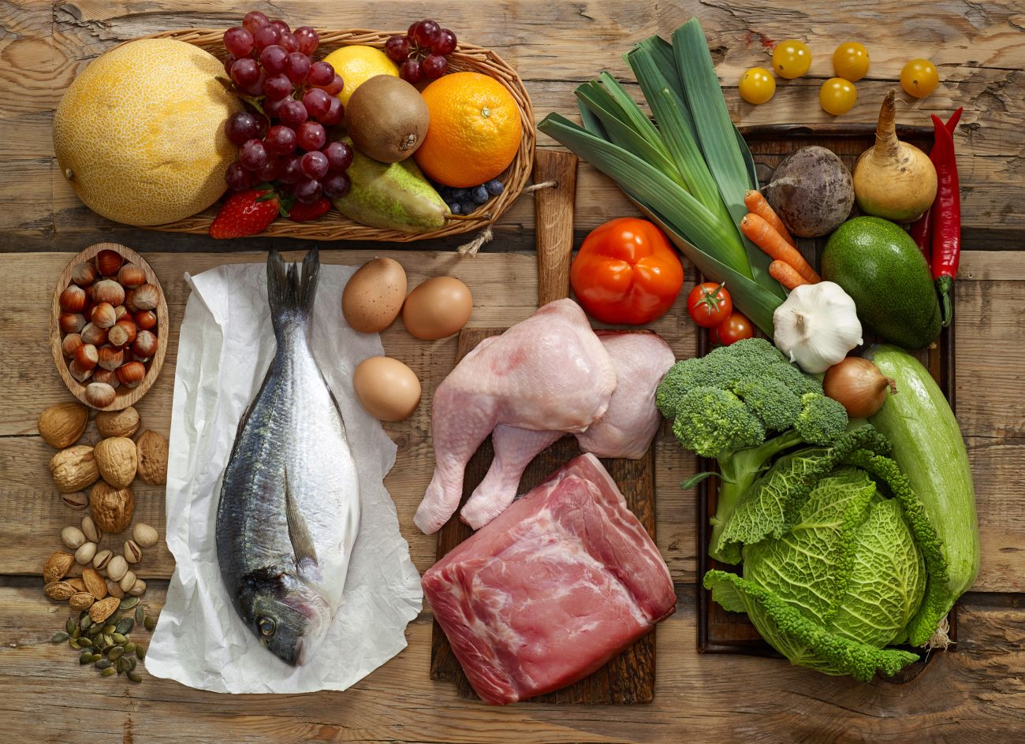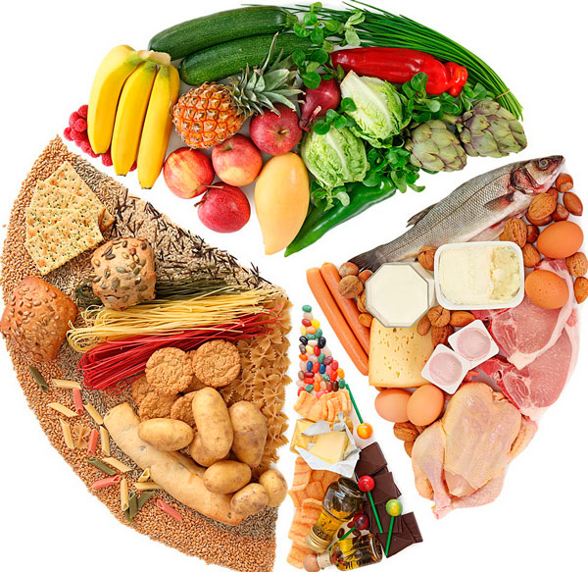

Application 5

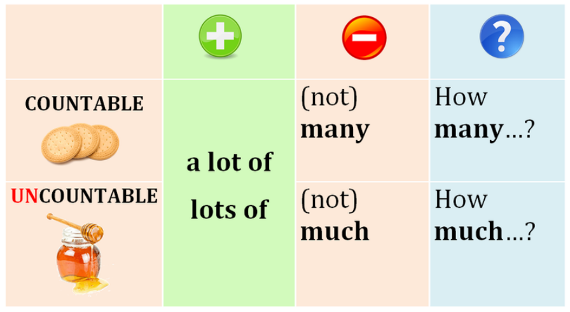

MANY
MUCH

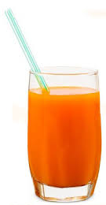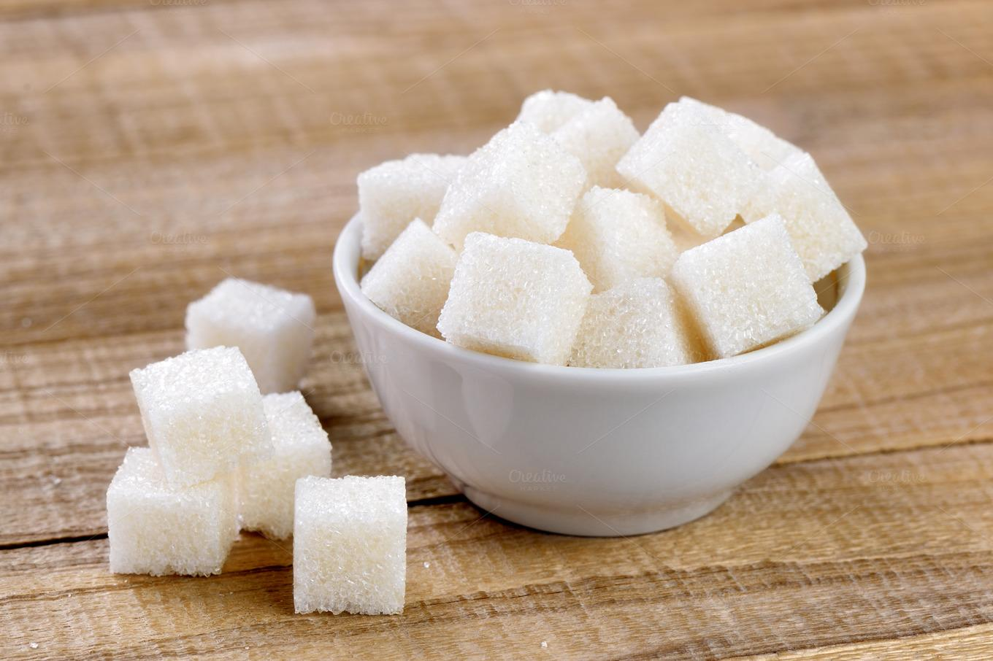
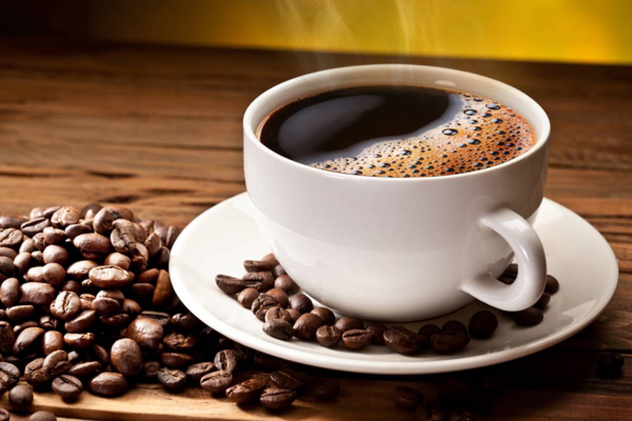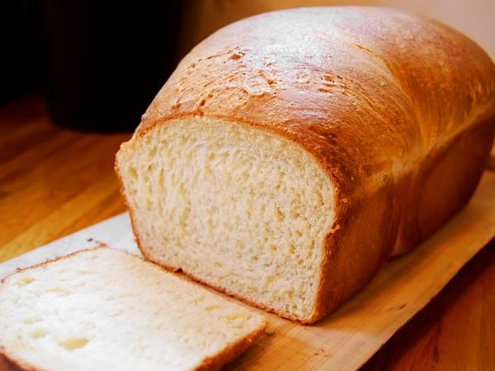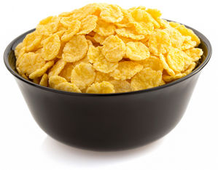
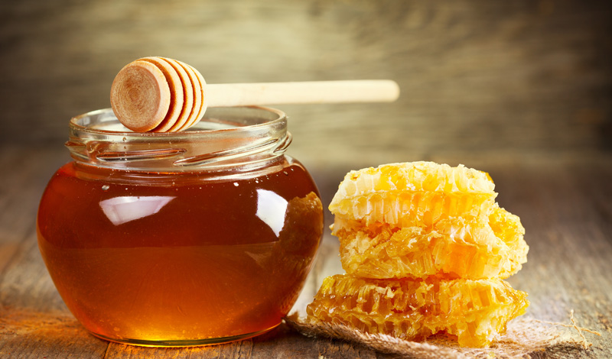
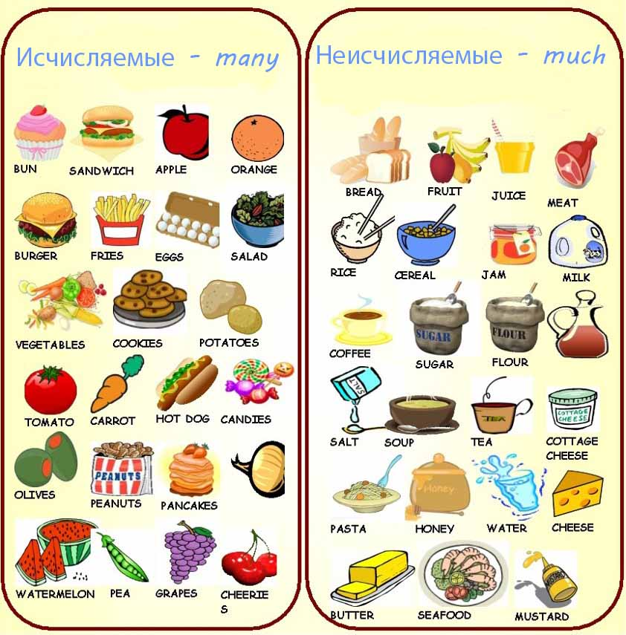
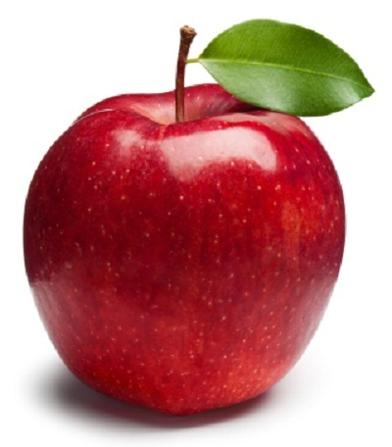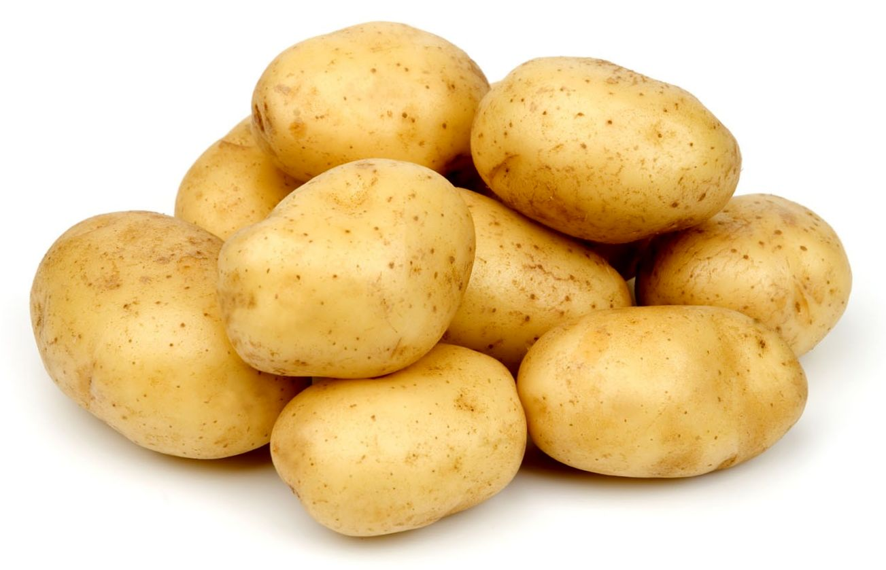
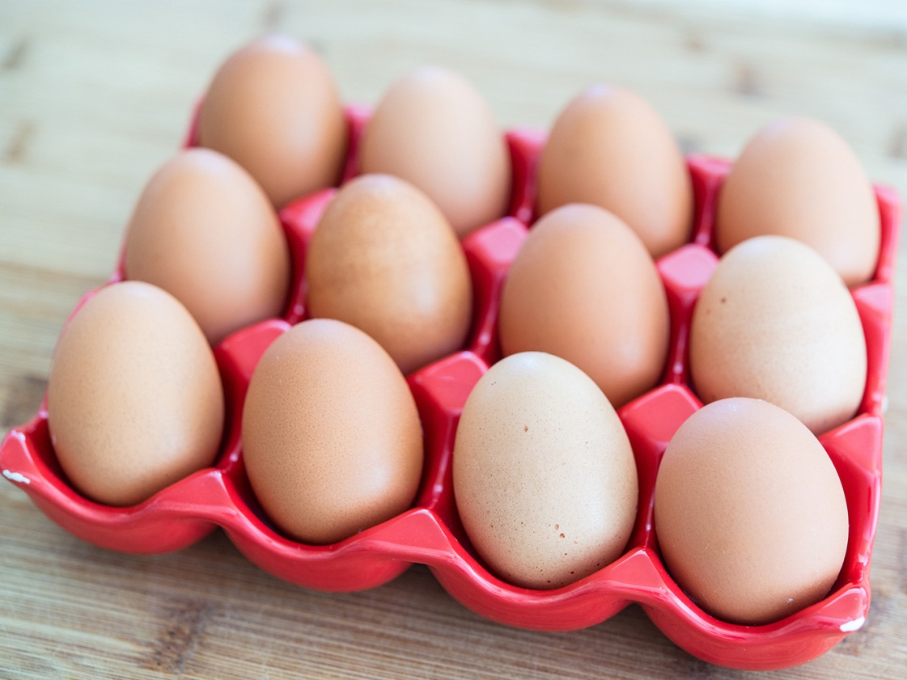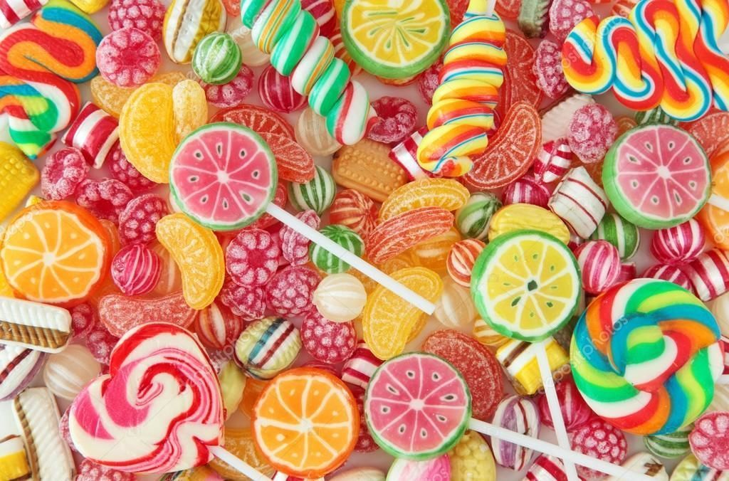
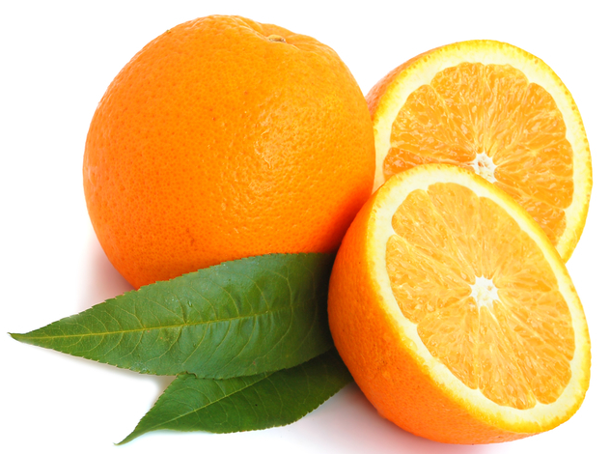
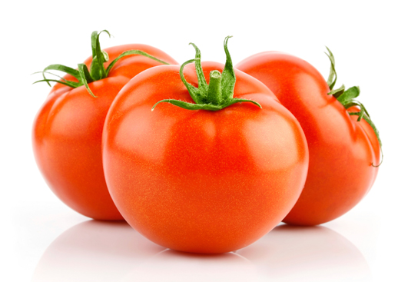

Application 6

Fill in the gaps a lot of, many, much

1. David drinks _____ apple juice.
2. Betty didn’t eat _______ rolls yesterday.
3. There isn’t _______ water in the glass.
4. We shouldn’t drink _______ cold milk.
5. There were __________ eggs in the fridge.
6. You shouldn’t eat _______ sweets.
7. Betty ate _______ honey yesterday.

